INNER JOIN

1. SELECT nama_karyawan, karyawan.status_karyawan, nama AS tempat_kerja FROM karyawan INNER JOIN cabang USING (id_cabang);

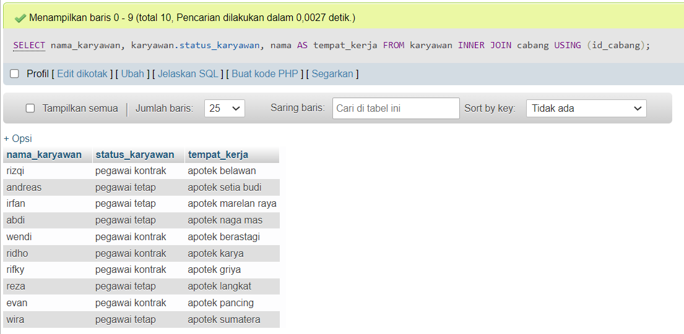

1. SELECT nama_karyawan, karyawan.status_karyawan, cabang.nama AS cabang, cabang.alamat AS alamat_kantor FROM karyawan INNER JOIN cabang ON karyawan.id_cabang = cabang.id_cabang ORDER BY cabang.id_cabang;

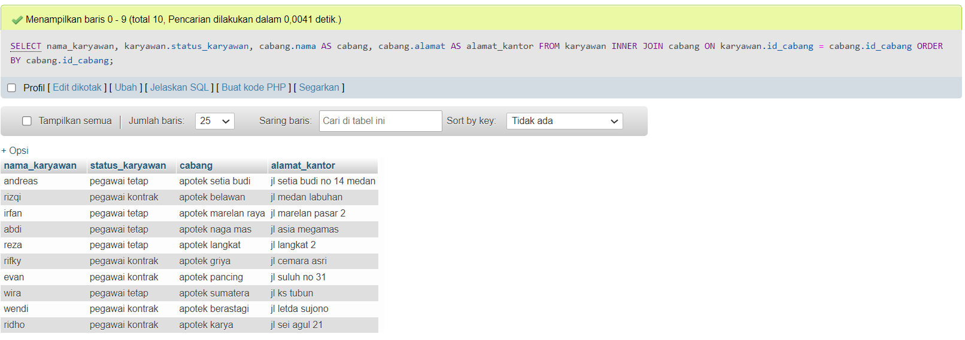

1. SELECT nama_karyawan, karyawan.status_karyawan, cabang.nama AS cabang, cabang.alamat AS alamat_kantor FROM karyawan INNER JOIN cabang ON karyawan.id_cabang = cabang.id_cabang WHERE cabang.alamat LIKE '%medan%' ORDER BY cabang.id_cabang;

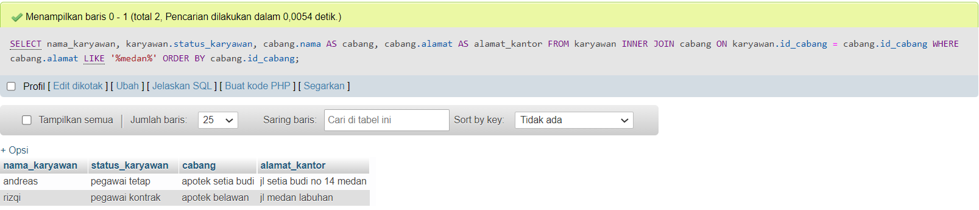

LEFT JOIN

1. SELECT customer.nama , orders.id_customer AS customer_order FROM customer LEFT JOIN orders USING (id_customer);

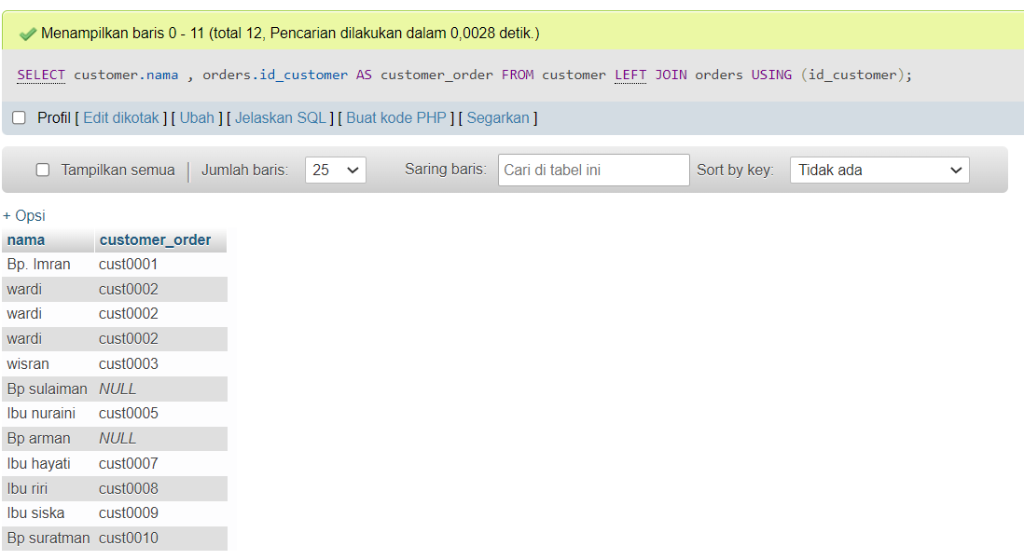

1. SELECT customer.nama , orders.id_customer AS customer_order FROM customer LEFT JOIN orders USING (id_customer) WHERE orders.id_customer IS NULL;

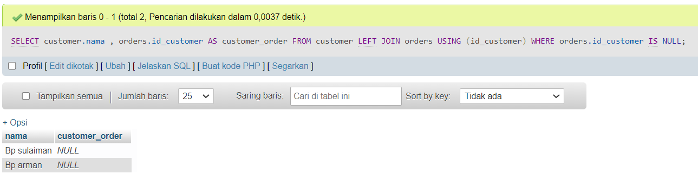

RIGHT JOIN

Kebalikan dari left join, konsep nya sama.